Meet Entries On-Line

Moving forward all Meet Entries will be done on-line. The Meet Entry fee will be added to your account and will be processed when fees are processed. My pictures might be slightly different to yours. Please follow the steps 1 - 7

Step 1: log onto your account (if you don’t know how to please speak to membership)

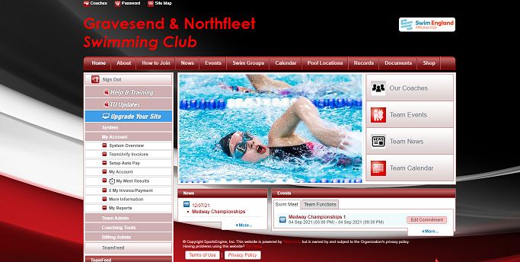

Step 2: Click on events
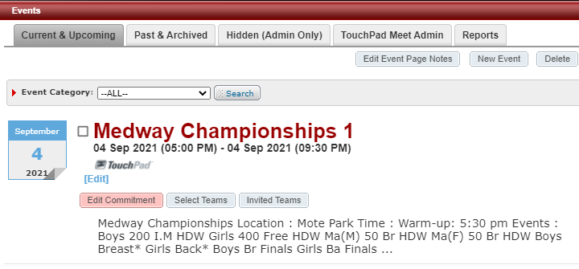

Step 3: Click on edit commitment
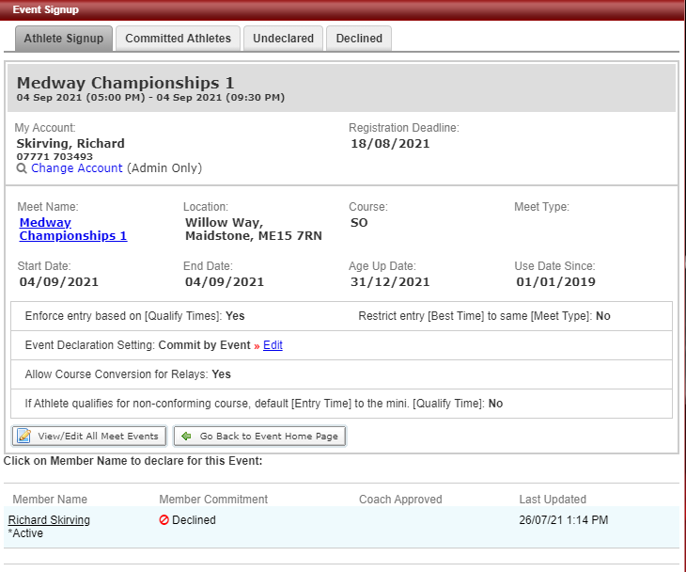
Step 4: Click on member name
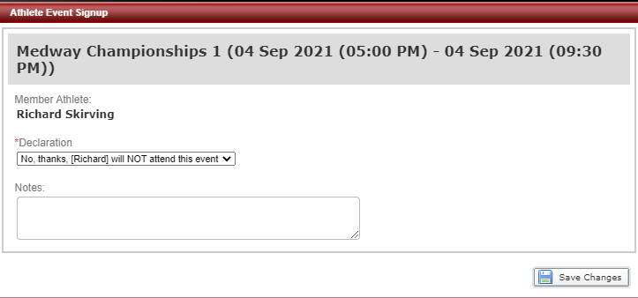

Step 5: Click Yes, please sign me up to the event

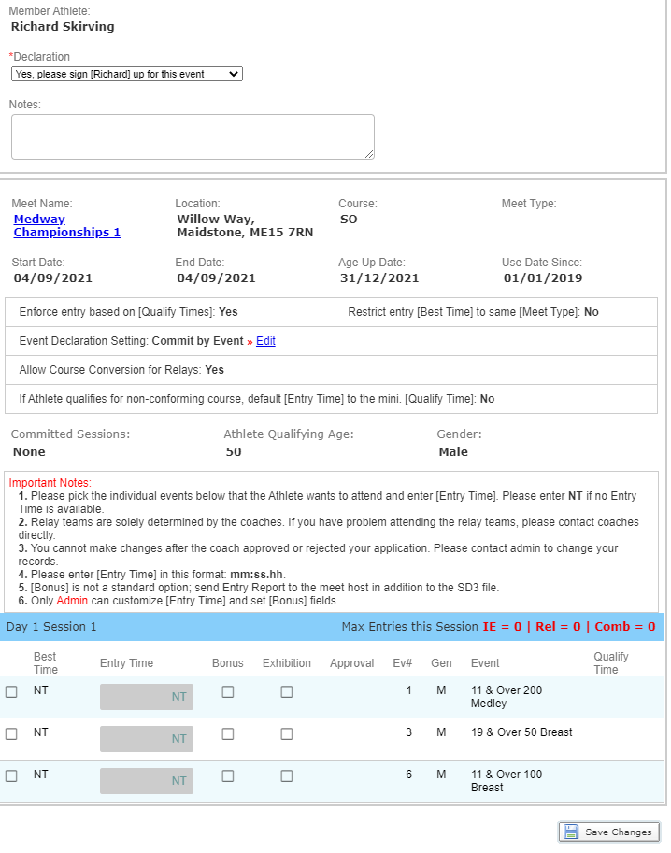

Step 6: Scroll to the bottom of the page and click the box to sign in for each event you wish to enter, the box will go yellow. The fastest time will appear in the yellow box or NT for no time.
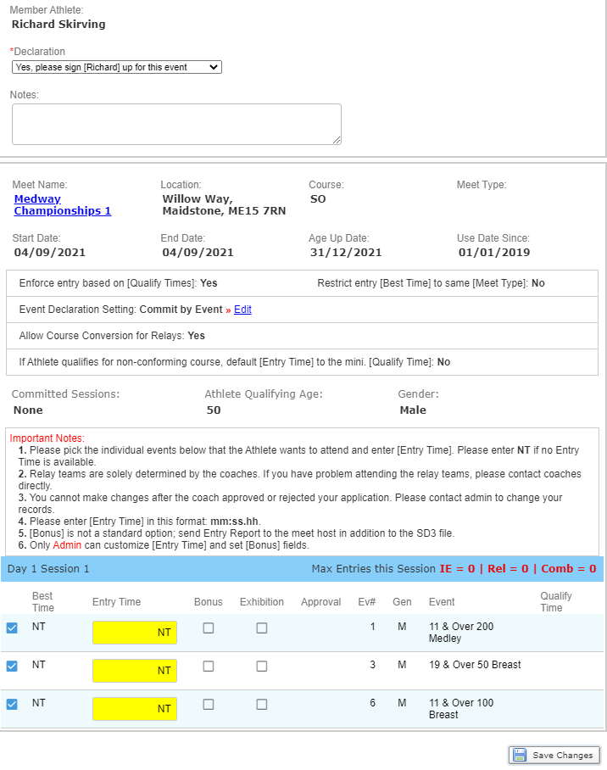
Step 7: Once you have entered all the events you wish to enter, Click save changes
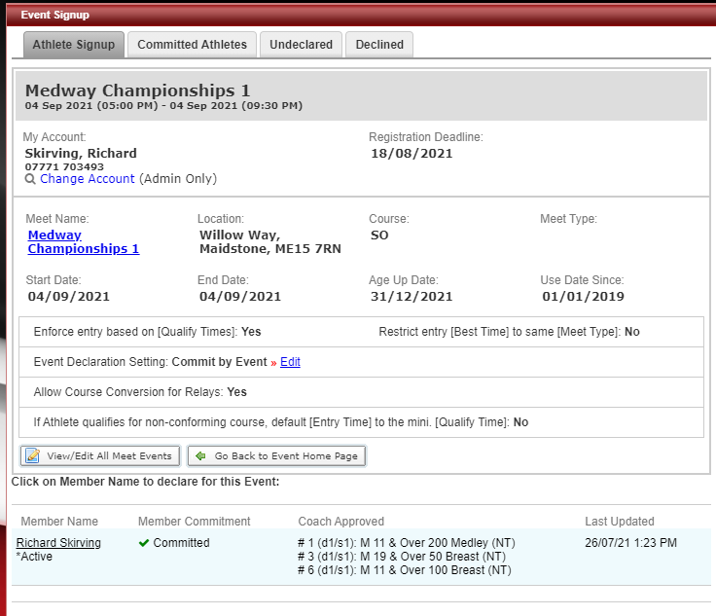

Once you have saved changes it will take you back to this screen and show what events have been entered for that swimmer.

You will need to repeat the process if you are entering more than one swimmer.

